Inventory Module

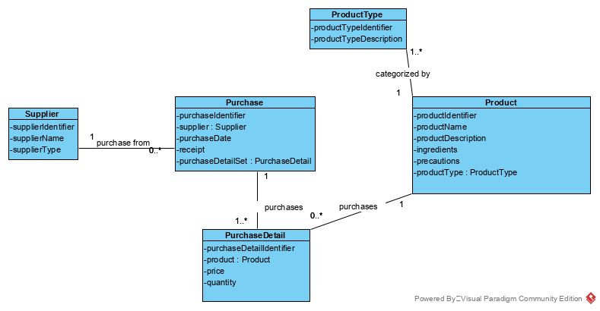Class diagram

Use Case: Maintain Product

User Story

As the owner of this business, I would like to record the products that I use for easy information retrieval. I want to be able to quickly show my customers the ingredients in the products.

Acceptance Criteria:

1. Must be able to record critical information about each product.
2. Allow deletion of products, in case the owner makes a mistake. Owner must be prompted to confirm and product must not be involved in any purchase orders.
3. Must be able to easily retrieve product information including ingredients and precautions for use.
4. Must be able to retrieve a list of products by product type, so that owner can retrieve all shampoo products, conditioner products, etc.

|  |  |  |  |
| --- | --- | --- | --- |
| Use Case Name | Create Product Information | | |
| Triggering Event | A new product of interest to the business | | |
| Brief Description | Allows the Owner to record a new product. | | |
| Actors | Owner | | |
| Related Use Cases |  | | |
| Preconditions | Owner has opened the Main Menu. | | |
| Post Conditions | Product is saved to the database and now can be purchased or used in a service. | | |
| Flow of activities | Actor | | System |
|  |  | Requests to add a new product | Displays a list of product types and prompts for selection. |
|  |  | Selects product type | Verifies that product type was selected. Prompts for Product identifier, product name, description, ingredients, and any precautions for use. |
|  |  | Enters product identifier, name, description, ingredients and precautions for use. | Identifier, name, description and ingredients must be entered.  Data is valid  Prompts to save |
|  |  | Request to save | Saves the product and returns to the main menu |
| Exception Conditions | * Owner chooses to cancel adding the product | | |

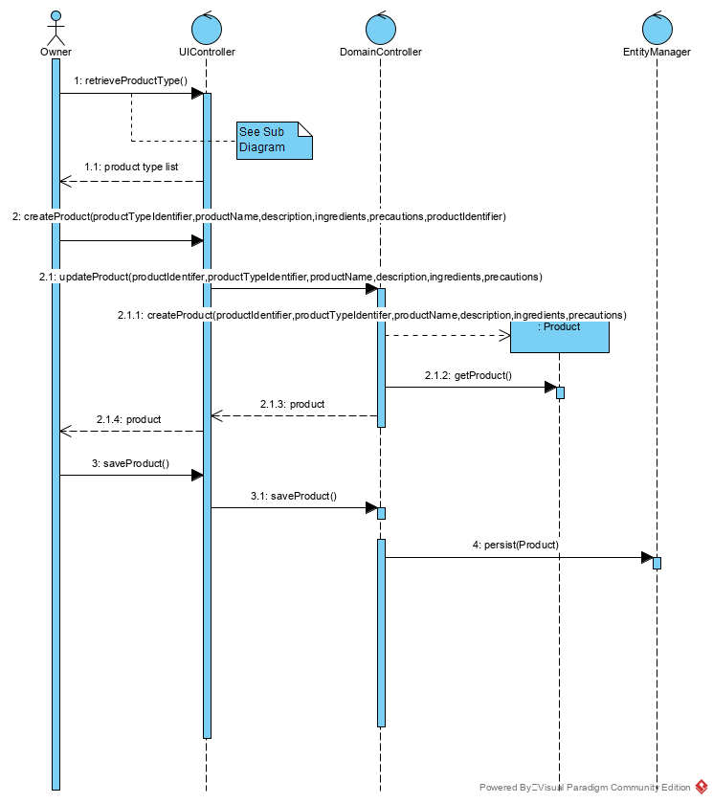

retrieveProductType

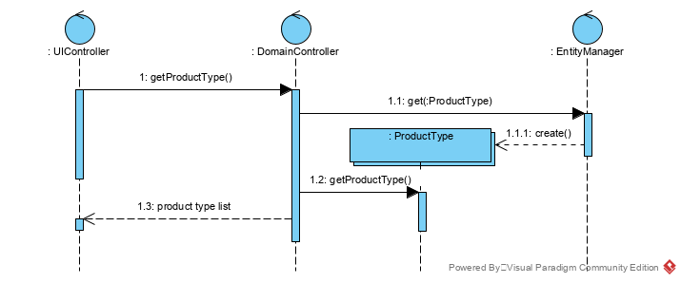

Use Case: Maintain Purchase

User Story

As the owner of this business, I would like to record my purchases so that I can quickly see how much money I’ve spent, what I’ve ordered and from where.

Acceptance Criteria:

1. Must be able to record purchases by supplier.
2. Differentiate between scheduled (bought online) and emergency purchases (bought in store).
3. Must be able to query purchases by product and by product type (example shampoo).

Use Case Descriptions

|  |  |  |  |
| --- | --- | --- | --- |
| Use Case Name | Create Purchase | | |
| Triggering Event | Purchase of a product. | | |
| Brief Description | Allows the Owner to record a new purchase. | | |
| Actors | Owner | | |
| Related Use Cases |  | | |
| Preconditions | Owner has opened the Main Menu. | | |
| Post Conditions | Purchase is saved to the database and now can be queried. | | |
| Flow of activities | Actor | | System |
|  | 1. | Requests to add a new purchase | Displays a list of suppliers and prompts for selection. |
|  | 2. | Selects a supplier. | Verifies that a supplier was selected. Prompts for purchase date and selection of receipt file location. |
|  | 3. | Enters purchase date and receipt file selected. | Verifies that date was entered and receipt selected.  Creates a unique identifier for the purchase. Prompts to enter product details. |
|  | loop | Chooses new detail | Displays a list of product and prompts for selection. Prompts for price, quantity ordered, and quantity received |
|  | 4. | Selects a product and enters price and quantity. | Product must be selected.  Price and quantity must be entered  Data is valid  Extended price is calculated (price * quantity ordered)  Taxes are calculated and displayed  Purchase total is updated with the extended price + taxes  Purchase tax is updated with the tax amount  Displays purchase including totals, date and list of products.  Prompts to add another product |
|  | End | When all products selected | Displays purchase including totals, date and list of products.  Verifies that at least one product has been selected.  Prompts to save purchase |
|  | 5. | Chooses to save | Saves the purchase and returns to the main menu |
| Exception Conditions | * Owner chooses to cancel adding the purchase | | |

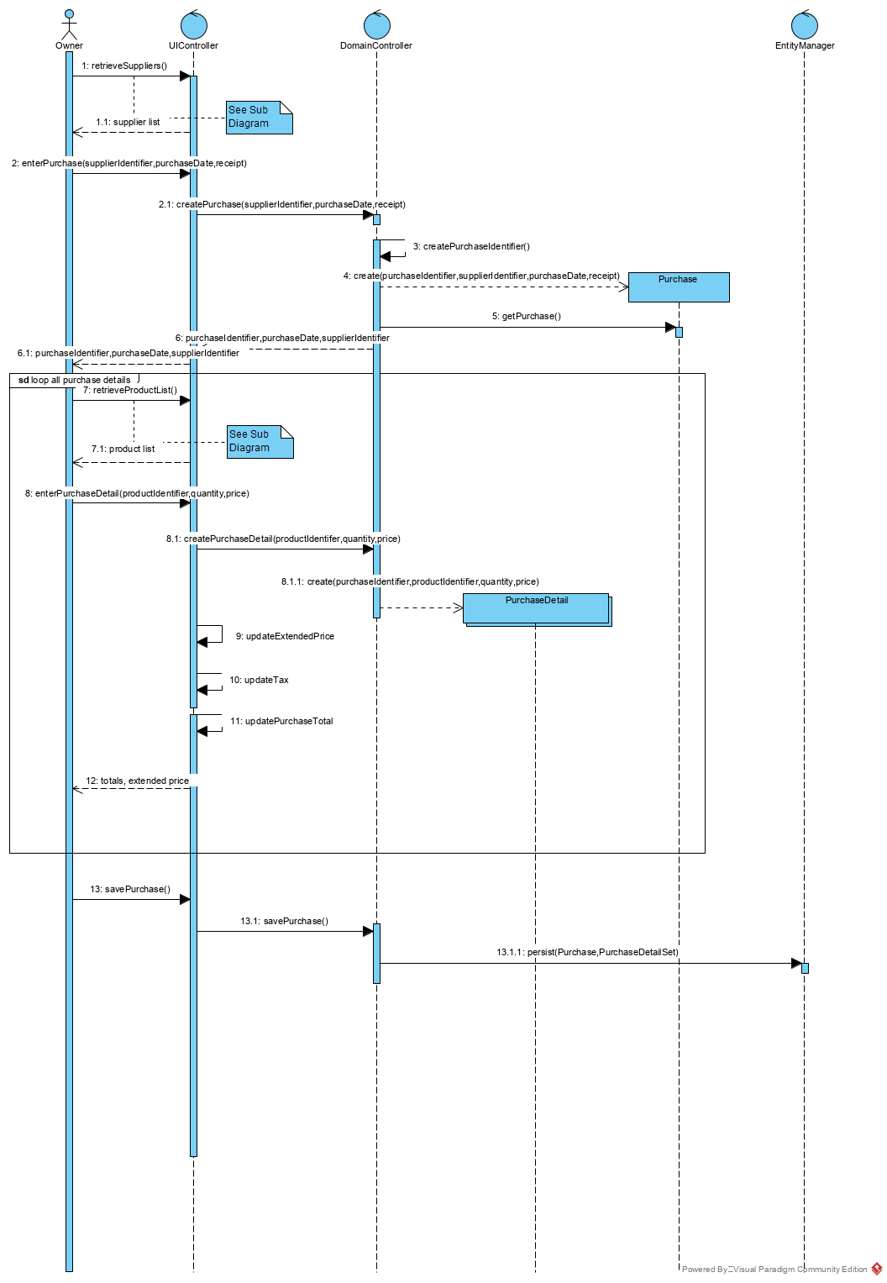

retrieveSuppliers

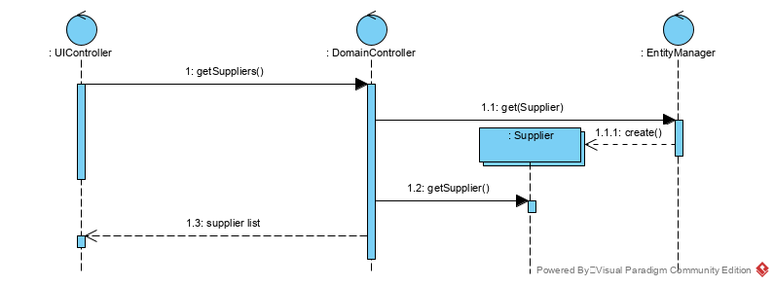

retrieveProductList

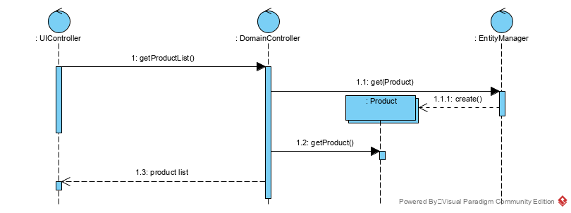

|  |  |  |  |
| --- | --- | --- | --- |
| Use Case Name | Query Purchases | | |
| Triggering Event | Owner requires a list of purchases for a date period listing Supplier, Products quantity purchased, price paid and the extended amount (price * quantity) | | |
| Brief Description | Allows the Owner to retrieve purchases for a specified date range | | |
| Actors | Owner | | |
| Related Use Cases |  | | |
| Preconditions | Owner has opened the Main Menu. | | |
| Post Conditions | purchases are retrieved, totaled and displayed | | |
| Flow of activities | Actor | | System |
|  |  | Requests to query purchase (by date) transactions | Displays a calendar |
|  |  | Selects date range | Verifies that dates are selected  Retrieves purchases in the specified date range  Prompts to exit |
|  |  | Request to cancel | returns to the main menu |
| Exception Conditions |  | | |

